Computer Programming – Lab
BSCS [1B]
FINAL TERM PROJECT REPORT


DEPARTMENT OF COMPUTER SCIENCES
BAHRIA UNIVERSITY, LAHORE CAMPUS

PROJECT NAME
Money Manager

Submitted by Group # 4:
Rao Zubair Nasir-075 (Leader)
Muhammad Hassan Baig-053
Muhammad Zain Akram-070
Muhammad Haseeb Akbar-052
Shehroz Ashraf Khan-080

Submitted to: Zupash Awais

Table of Contents
1. Marks Distribution 3
2. Abstract 4
3. Introduction 5
4. Problem Statement 5
5. Objectives 5
6. Methodology 5
7. Results 5
8. Code 5
9. References 5

Marks Distribution
------------------------------ For Instructor Use Only ----------------------------------
Project Grading Sheet
Sr. No. | Task | Max Marks | Obtained Marks | Comments(if any)
1. | Report | 05
2. | Implementation | 10
3. | Viva  (Oral/Task Based or Both) | 15
Total |  | 30 |  | Signature:
--------------------------------------------------------------------------

Abstract

The basic purpose of this project is to take control on the daily user budget. The project first creates a profile of a user and after all it take input from the user like personal information and source of income.
After generating the profile, it takes information from user like daily expenses and much more. Now it tells about our daily usage amount and return the remaining balance.
At the End there is another DISPLAY function that tells us about it saving and remaining balance amount.

Introduction
Money management is an important and unavoidable activity which most people dread. Money management not only involves handling investments but also includes managing multiple accounts and tracking expenses. Each of these activities involves accessing information from different locations and so collecting and consolidating monetary information is not easy.
Currently, there are some standalone personal finance applications which address different issues of financial management.
Project: The basic purpose of this project is to take control on the daily user budget. The project first creates a profile of a user and after all it take input from the user like personal information and source of income.
After generating the profile, it takes information from user like daily expenses and much more. Now it tells about our daily usage amount and return the remaining balance.
At the End there is another DISPLAY function that tells us about it saving and remaining balance amount.
Motivation: The motivation of this project is to make a schedule for peoples to maintain their daily budget and help them to save and use their money in a proper way.
Usage and Advancement: This type of Apps and modules are used in Marketing purpose and in banking.

Problem Statement
People faces to much problems to maintain their daily budget and uses extra amount.
If they wanted to save their money, then this Project helps them to solve their problem for saving

Objectives
From this project we learn how to:
- Use loops
- Use Conditions
- Use switches
- Use Structure Statement
- Use Stings

Methodology
We use Library (iomanip, iostream, string), data type (Structure {struct}), Loops (For, Do, While), Conditions (If else), Switches.
Library:
In the C++ programming language, the C++ Library is a collection of classes and functions, which are written in the core language and part of the C++ ISO Standard itself.
Data Type:
A data type or simply type is an attribute of data which tells the compiler or interpreter how the programmer intends to use the data.
Loops:
A loop statement allows us to execute a statement or group of statements multiple times and following is the general from of a loop statement in most of the programming languages - C++ programming language provides the following type of loops to handle looping requirements.
Conditions:
Conditions are expressions that evaluate to a boolean value, a true or false value (true and false are C++ keywords, representing the two possible values of a boolean expression or variable).

Results
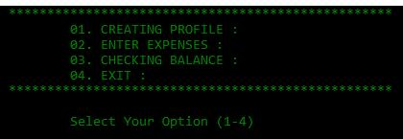
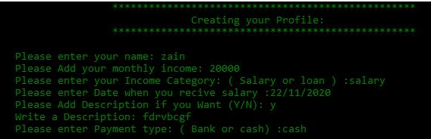
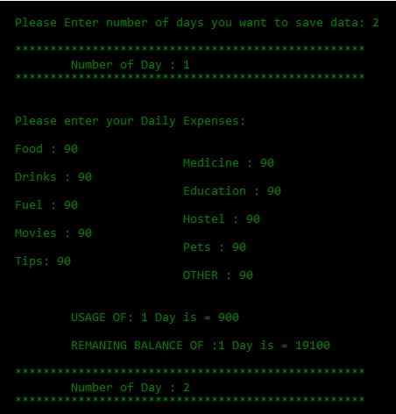
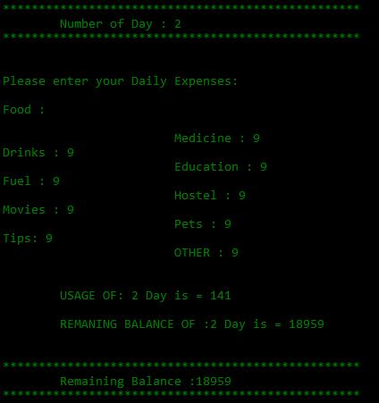
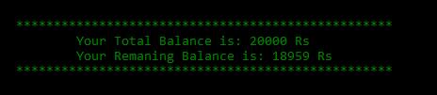

Code
#include<iostream>
#include<iomanip>
#include<string>
#include<fstream>
using namespace std;
struct money
{
string name;
double income, days, remaing;
string category, date, desciption, type;
char choise;
}e;

void main()
{
money e;

char ch;
system("COLOR 02");
do{
cout << "\t\t\t\t" << setw(50) << setfill('*') << "*" << endl;
cout << "\t\t\t\t\t01. CREATING PROFILE : " << endl;
cout << "\t\t\t\t\t02. ENTER EXPENSES : " << endl;
cout << "\t\t\t\t\t03. CHECKING BALANCE : " << endl;
cout << "\t\t\t\t\t04. EXIT : " << endl;
cout << "\t\t\t\t" << setw(50) << setfill('*') << "*" << endl;
cout << "\n\t\t\t\t\tSelect Your Option (1-4) ";

cin >> ch;
if (ch == '1')
{
system("cls");
ofstream iout("sample1.txt");
cout << "\t\t\t\t" << setw(50) << setfill('*') << "*" << endl;
cout << " \t\t\t\t\t Creating your Profile: " << endl;
cout << "\t\t\t\t" << setw(50) << setfill('*') << "*" << endl << endl;

cin.ignore();
cout << "\t\tPlease enter your name: ";
getline(cin, e.name);
iout << "\t\tUser name " + e.name<<endl;

cout << "\t\tPlease Add your monthly income: ";
cin >> e.income;
iout << "\t\tBalance of " << e.name<<" is " << e.income<<" Rs \n";
cout << "\t\tPlease enter your Income Category: ( Salary or loan ) :";
cin >> e.category;
iout << "\t\tIncome Category: " << e.category<<endl;
cout << "\t\tPlease enter Date when you recive " << e.category << " :";
cin >> e.date;
iout <<"\t\t"<< e.category << " Recive date: " << e.date<<endl;
iout.close();
cout << "\t\tPlease Add Description if you Want (Y/N): ";
cin >> e.choise;
if (e.choise == 'Y' || e.choise == 'y')
{
cout << "\t\tWrite a Description: ";
cin >> e.desciption;
}
else if (e.choise == 'N' || e.choise == 'n')
{
}
cout << "\t\tPlease enter Payment type: ( Bank or cash) :";
cin >> e.type;

system("cls");
cout << endl << endl;
cout << "\t\t\t\t" << setw(50) << setfill('*') << "*" << endl;
cout << " \t\t\t\t You have Successfully created your Profile: " << endl;
cout << "\t\t\t\t" << setw(50) << setfill('*') << "*" << endl;
cout << endl << "\t\t\t\t" << " Welcome: " << e.name << endl << endl;

}

else if (ch == '2')
{
system("cls");
cout << endl;

cout << "\t\t\t\tPlease Enter number of days you want to save data: ";
cin >> e.days;
cout << endl;

e.remaing = e.income;
for (int i = 0; i < e.days; i++)
{
double food, medicine, drink, education, fuel, hotel, movies, pets, tips, other;

cout << "\t\t\t\t" << setw(50) << setfill('*') << "*" << endl;
cout << "\t\t\t\t\tNumber of Day : " << i + 1 << endl;
cout << "\t\t\t\t" << setw(50) << setfill('*') << "*" << endl << endl << endl;
cout << "\t\t\t\tPlease enter your Daily Expenses: " << endl << endl;
cout << "\t\t\t\tFood : ";
cin >> food;
e.remaing -= food;

cout << "\t\t\t\t\t\t\tMedicine : ";
cin >> medicine;
e.remaing -= medicine;

cout << "\t\t\t\tDrinks : ";
cin >> drink;
e.remaing -= drink;

cout << "\t\t\t\t\t\t\tEducation : ";
cin >> education;
e.remaing -= education;

cout << "\t\t\t\tFuel : ";
cin >> fuel;
e.remaing -= fuel;

cout << "\t\t\t\t\t\t\tHostel : ";
cin >> hotel;
e.remaing -= hotel;

cout << "\t\t\t\tMovies : ";
cin >> movies;
e.remaing -= movies;

cout << "\t\t\t\t\t\t\tPets : ";
cin >> pets;
e.remaing -= pets;

cout << "\t\t\t\tTips: ";
cin >> tips;
e.remaing -= tips;

cout << "\t\t\t\t\t\t\tOTHER : ";
cin >> other;
e.remaing -= other;

cout << endl << endl;
cout << "\t\t\t\t\tUSAGE OF: " << i + 1 << " Day is = " << food + medicine + drink + education + fuel + hotel + movies + pets + tips + other << endl;
cout << endl << "\t\t\t\t\tREMANING BALANCE OF :" << i + 1 << " Day is = " << e.remaing << endl << endl;

}
ofstream hout("sample2.txt");
cout << endl;
cout << "\t\t\t\t" << setw(50) << setfill('*') << "*" << endl;

cout << "\t\t\t\t\tRemaining Balance :" << e.remaing << endl;
cout << "\t\t\t\t" << setw(50) << setfill('*') << "*" << endl;

hout << "\t\t"<<e.name << " Your Remaining Balance is : " << e.remaing << " Rs\n\n\n";
hout.close();

}
else if (ch == '3'){
system("cls");
cout << endl << endl;

ifstream iin,hin;
string output,output_balance;

iin.open("sample1.txt");
hin.open("sample2.txt");

while (iin.eof() == 0)
{

getline(iin, output);

cout << output << endl;

}

getline (hin, output_balance);
cout << output_balance;

}
else if (ch == '4')
{ system("cls");
cout << endl << endl;
cout << "\t\t\t\t" << setw(50) << setfill('*') << "*" << endl;
cout << "\t\t\t\t\t\tThanks for coming:" << endl;
cout << "\t\t\t\t" << setw(50) << setfill('*') << "*" << endl;
break;

}

cin.ignore();
cin.get();
} while (ch != '4');

system("pause");
}

References
Recorded Lectures only.

